A brief description of the project

I have to build a library management system using Django where an admin can perform CRUD ( create, read, update and delete) operations like

1. Add a Book
2. Update an entry of a book
3. Delete a book
4. Get all books

Developed this web service using Python (Django Framework) and HTML,CSS,Django Templates were used for the front end.

Installation instructions

1.Install Python

2.Install Django rest Framwork

pip install djangorestframework

3.Install mysqlclient

pip install mysqlclient

Project Requirements met

1. Admin Signup:

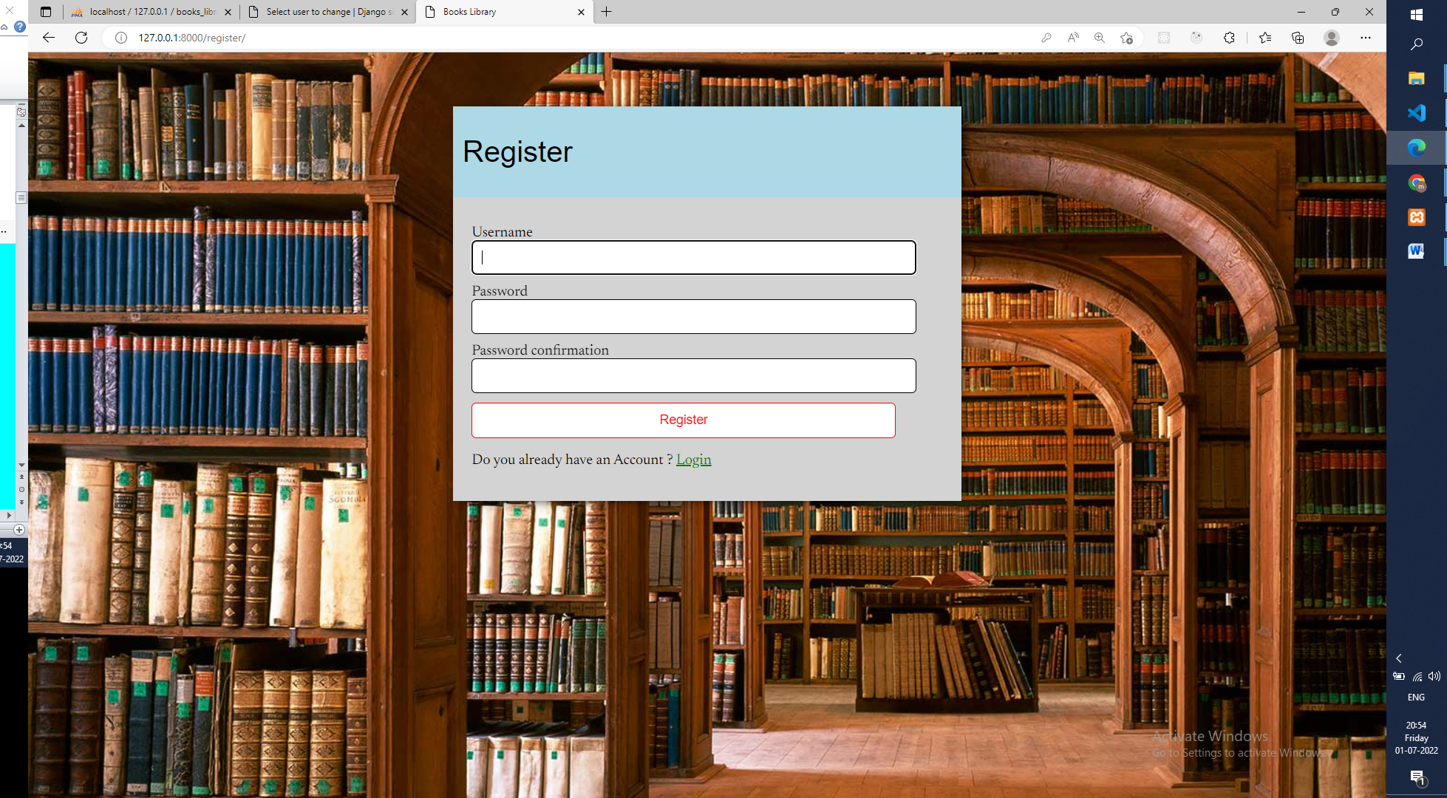

a) Insert admin details in tables.

b) An admin records should be unique based on email, which means duplicates records should not be able to enter in DB.

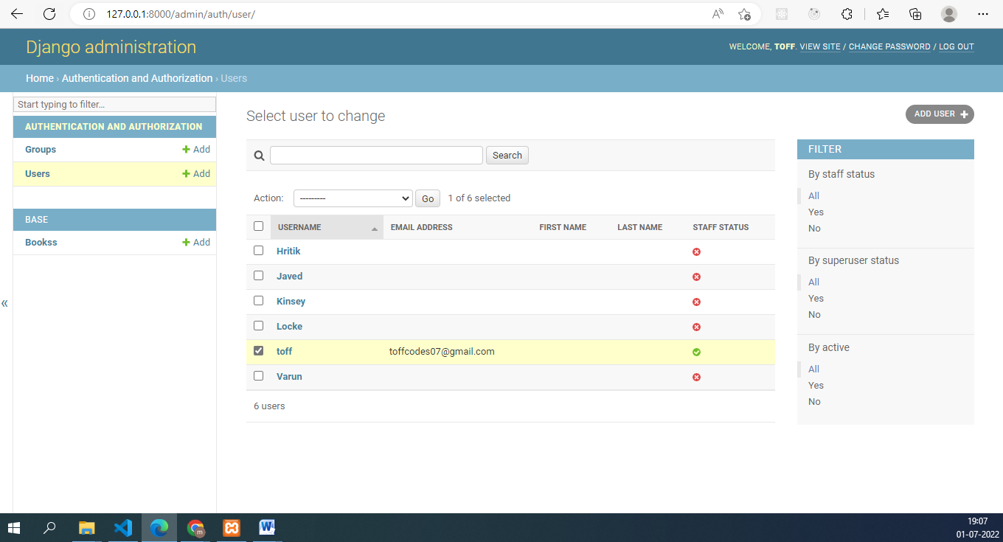

2. Admin Login: a) The Admin can log in based on email and password.

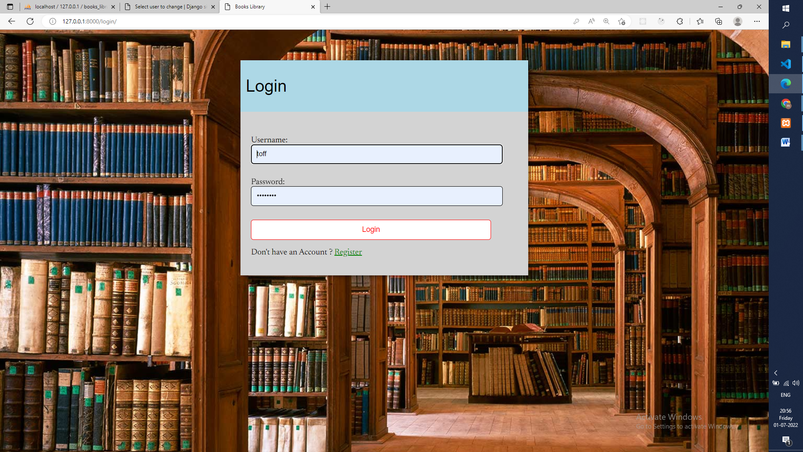

3. Create an entry for Books.

a) The admin can create a new entry of a book.

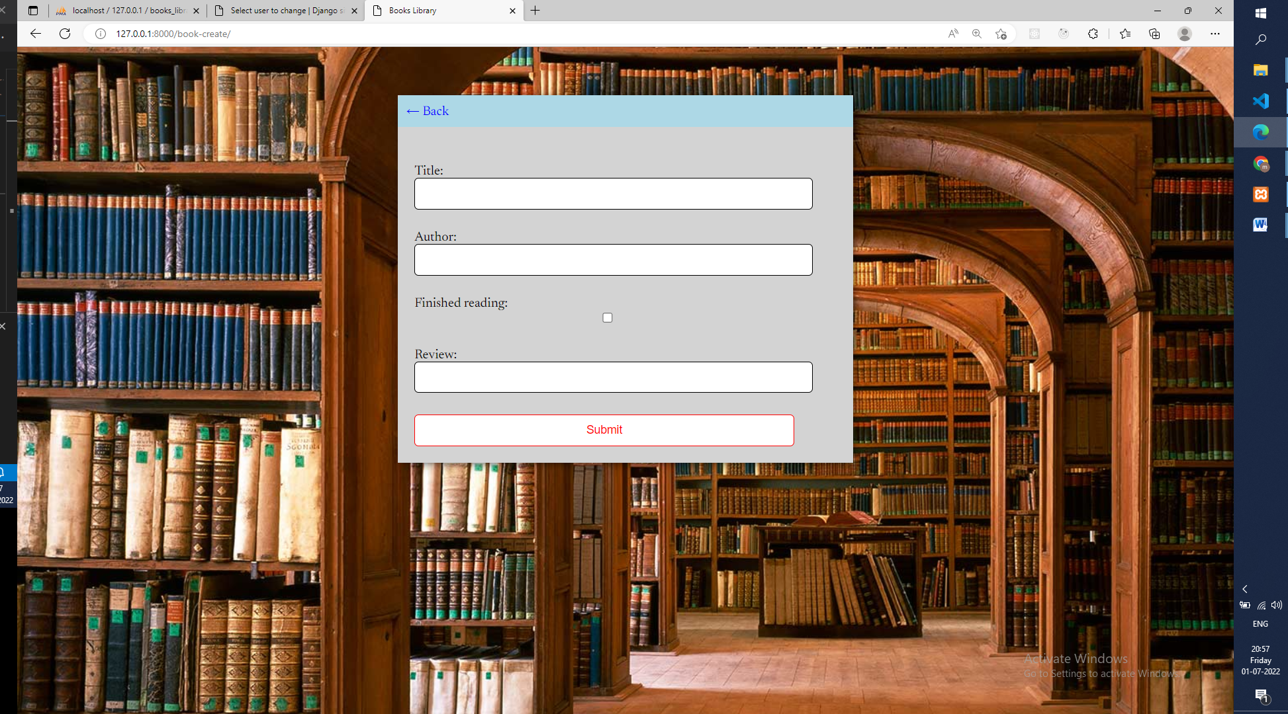

4. Retrieve all the books. a) Retrieve all the books.

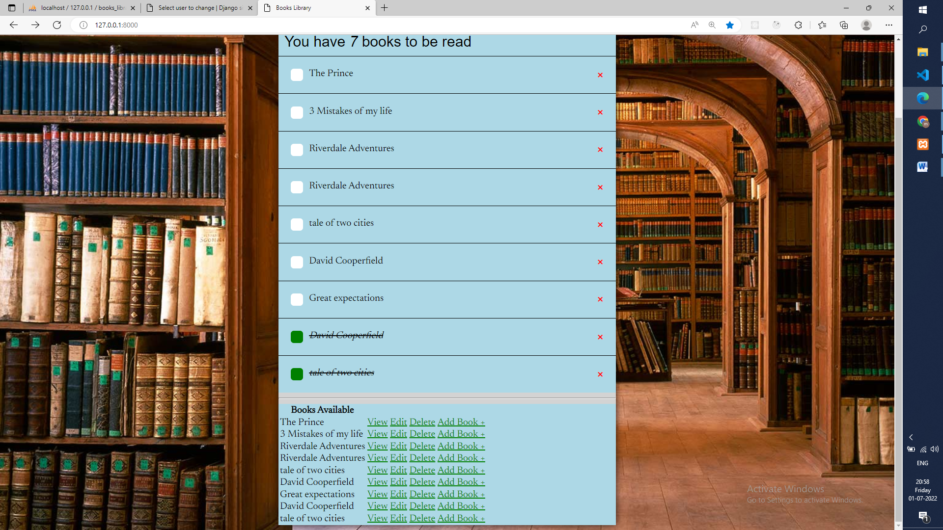

5. Update a book. a) The book records should be able to update.

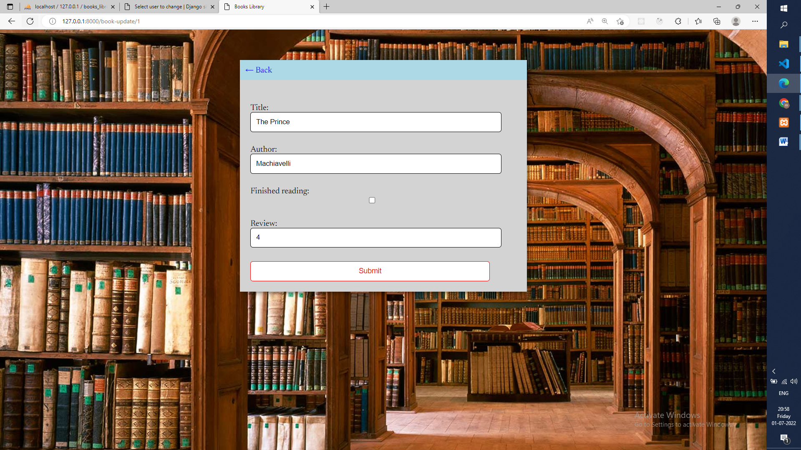

6. Delete a book. a) The book record should be deleted

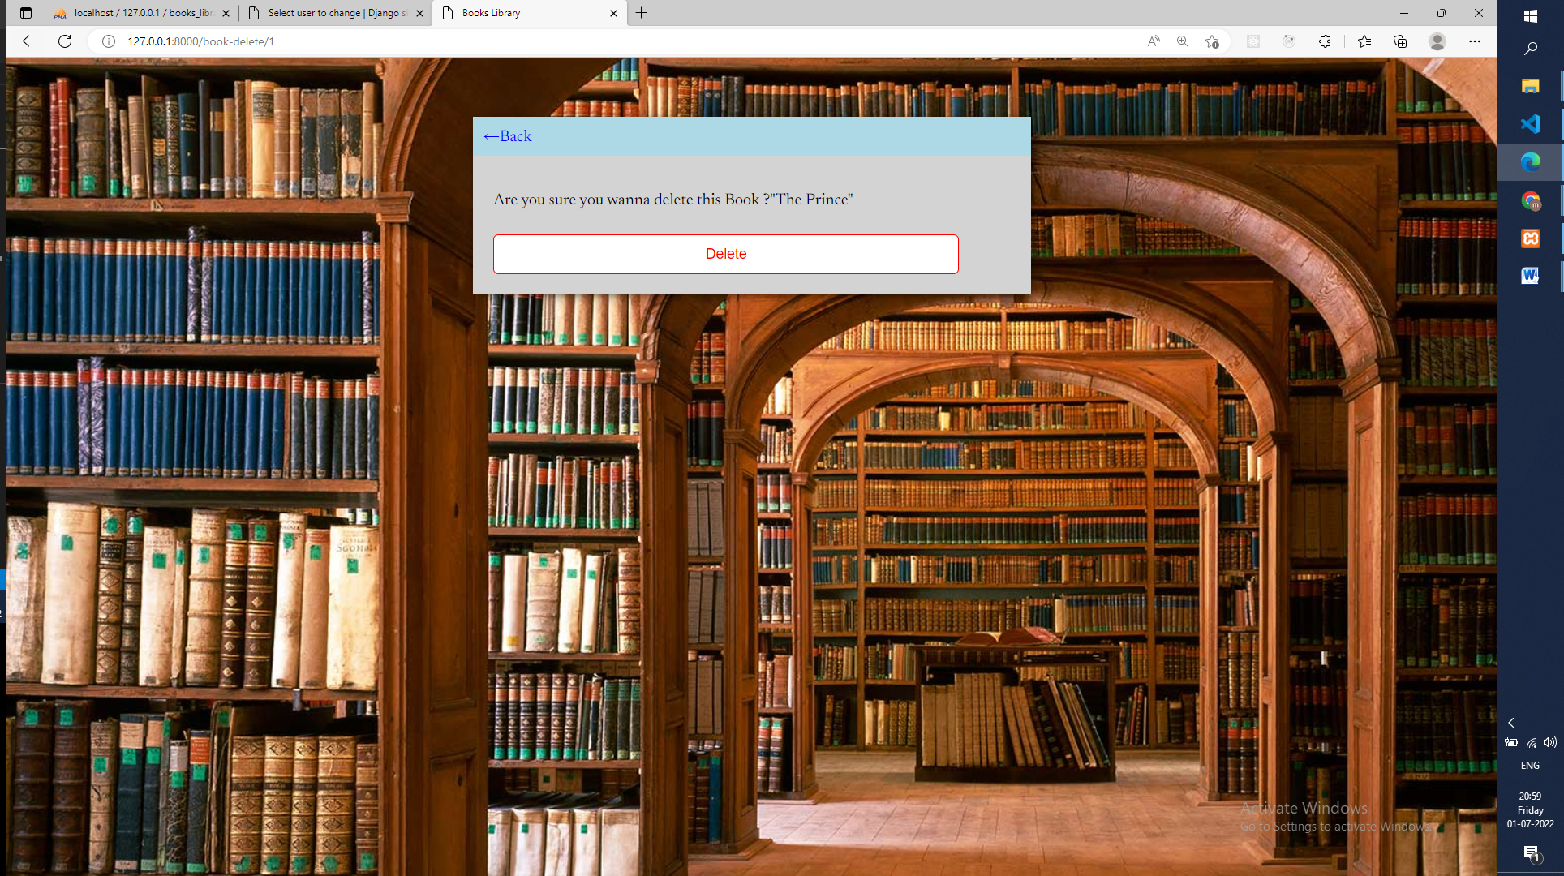

Student View:

1. View all the records of book

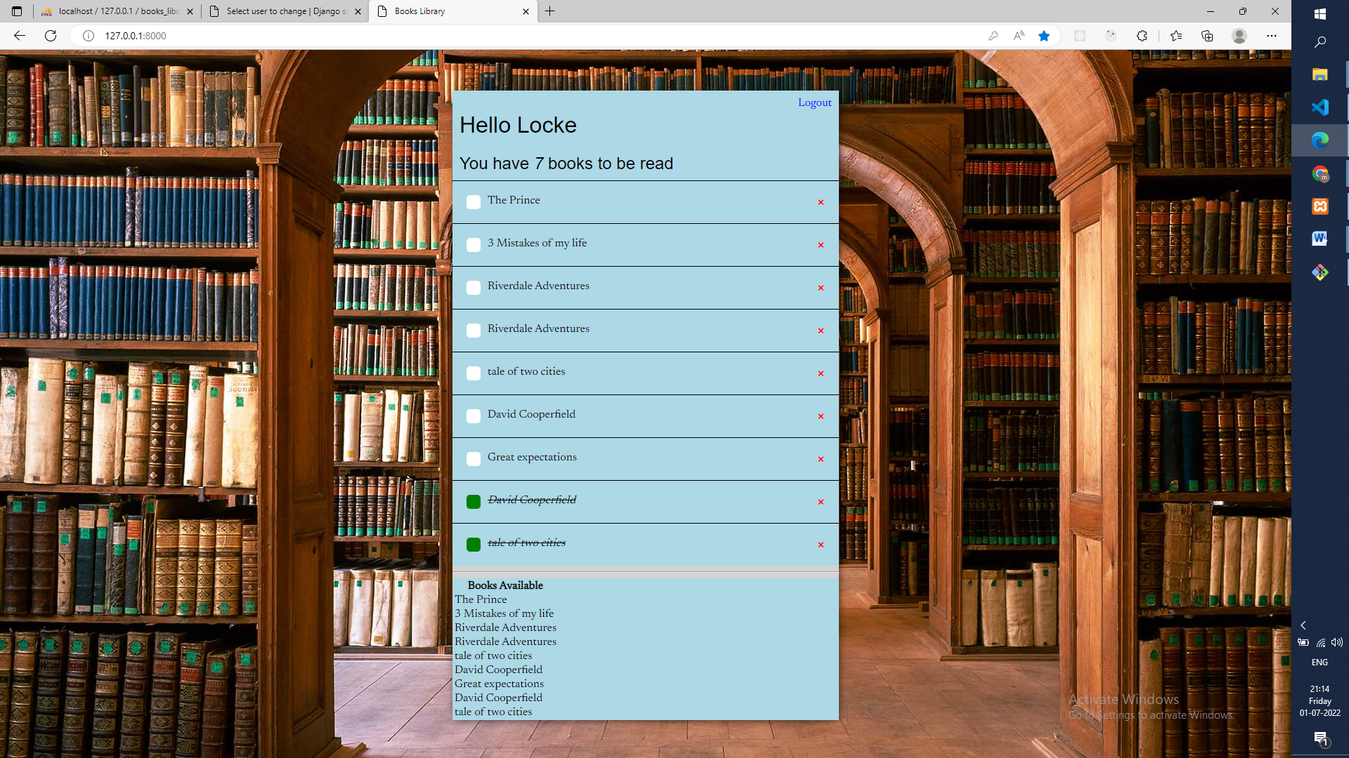

All Conditions met:

1. For Front end, you can use any library / framework to build the UI.

2. Write the documentation for backend code.

3. Use MySQL database to store the data

